Blue Buffalo Home 4 The Holidays Fact Sheet
and Basic Messaging

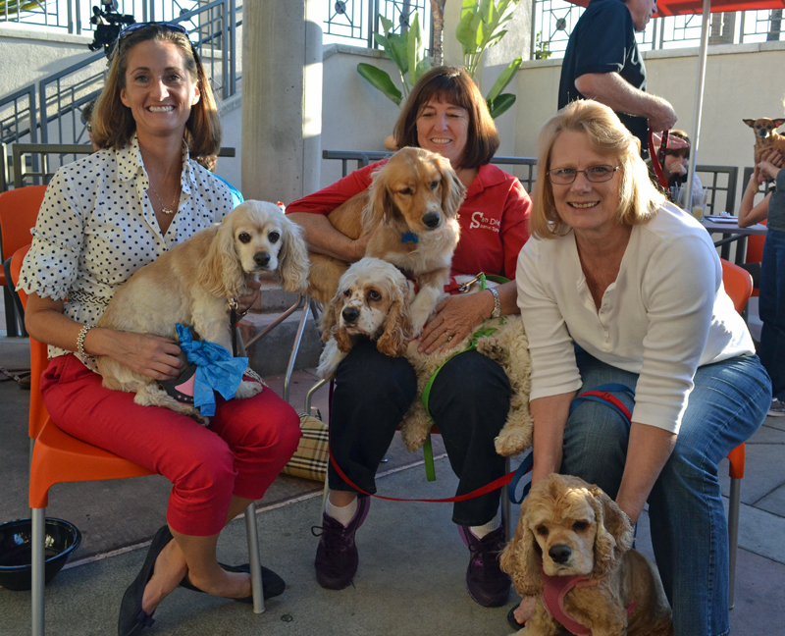

Overall Campaign Messages
- Blue Buffalo Home 4 the Holidays, one of the world’s largest annual pet adoption drives, begins October 1, 2022, and runs through January 2, 2023.
- In 1999, Helen Woodward Animal Center began the program with 14 participating shelters in San Diego County. Today, the partnership continues as we provide thousands of animal organizations from around the world guidance, marketing materials and press opportunities, to get more pets adopted this holiday season.
- Currently, over 4,000 pet adoption centers and rescue organizations across the globe participate in the program and working together, more than 19 million pets have been adopted to date.

Blue Buffalo Home 4 the Holidays Q&A
Q: What is Blue Buffalo Home 4 the Holidays?
A: Home 4 the Holidays is an annual, three-month pet-adoption campaign dedicated to helping place orphan pets into happy, loving homes. More families bring a new pet home during the holiday season than at any other time of the year. This program is dedicated to educating the public about the importance of choosing pet adoption over supporting puppy mills and backyard breeders. Through our collective group of over 4,000 pet adoption agencies, facilities and rescue-groups, this campaign has become the largest pet adoption campaign on record, saving over 19 million pets since its inception in 1999. The 2022 pet adoption drive begins October 1, 2022, and runs through through January 2, 2023.

Q: Why is the campaign only three months long?
A: Home 4 the Holidays promotes pet adoption every day of the year, but focuses on the holiday months because it can be a great time to bring a new family member home. Every pet deserves a forever, loving home. Statistically, we know the holidays are a time when people often make plans to adopt a pet. It’s important for programs like this to be available so people can be educated about how to ensure a successful, long-term adoption.

Q: I’ve always heard adopting a pet during the holidays isn’t a good idea.
A: Home 4 the Holidays does not advocate that pets be given as impulse gifts, however we do encourage and promote responsible adoptions. In the past some shelters have actually gone so far as to discourage families from adopting pets during the holidays – uncomfortable with the idea of a pet as an “impulse purchase.” This did not stop families from bringing home new pets. It just removed their adoption option and forced them to support the pet store and puppy mill industry. We feel that the adoption process actually removes “impulse” from the equation.

Unlike a pet store or puppy mill purchase, adopters must go through an application process; do a meet-and-greet with the orphan pet and an adoption department staff member; and discuss the home life in which the orphan pet will ultimately live, should the family decide to adopt. Additionally, participating Home 4 the Holidays rescue workers know that educating families about the value of orphan pets, and working with these families to match the perfect family with the ideal pet, means a better success for everyone involved. Everybody wins.

Q: How can people get involved in this program if they’re not looking to adopt a pet?
A: Even if you are not able to adopt a pet, there are still plenty of ways you can get involved to help homeless pets. Becoming a volunteer, donating to your local pet rescue and encouraging friends and family members to opt to adopt when seeking a new pet are just a few of the ways you can help. Check the list of participating organizations in your area on the campaign website at https://join.home4theholidays.org/shelter_map.aspx.

